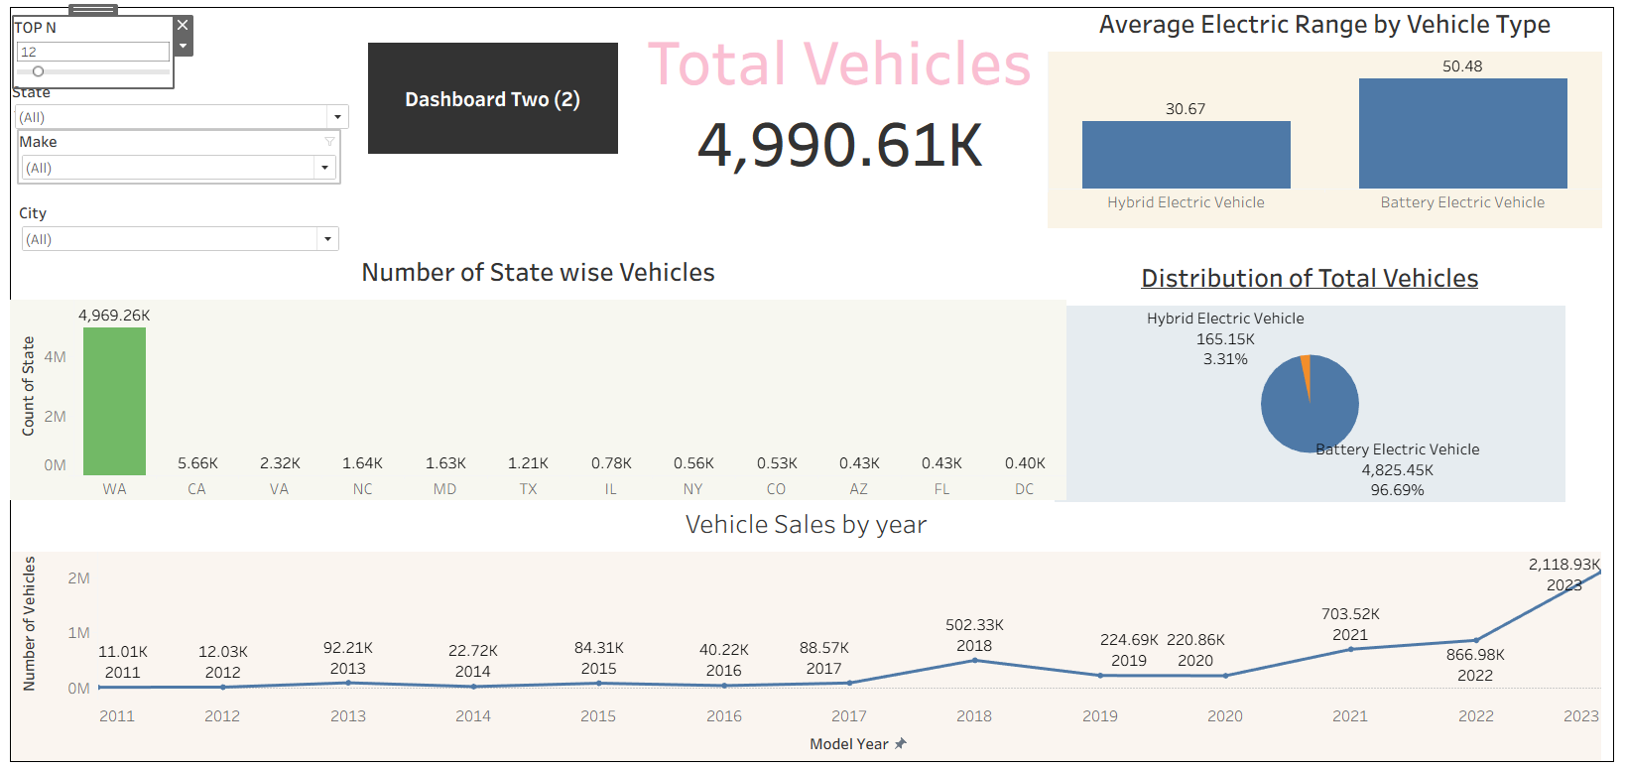
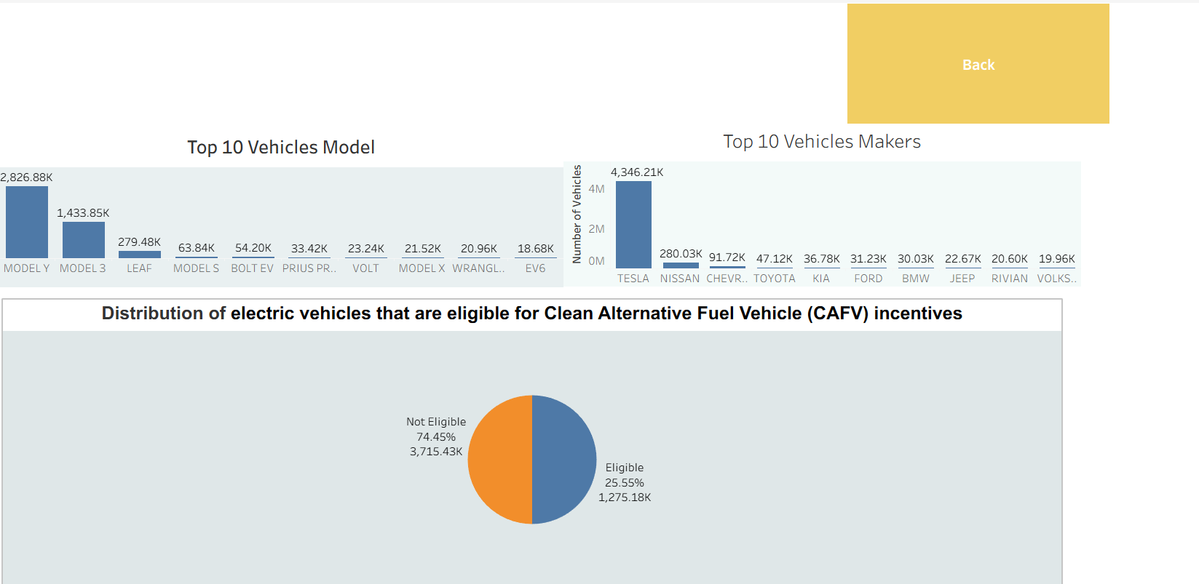

https://public.tableau.com/app/profile/anuj.salwan/viz/Anuj_Salwan/Story1?publish=yes

